
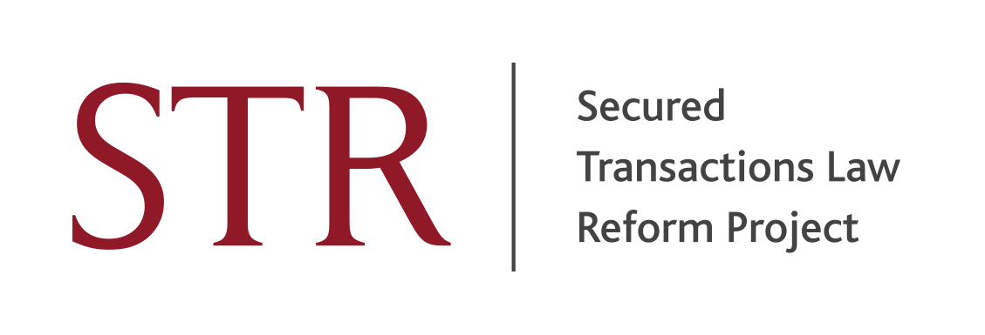
SECURED TRANSACTION REFORM IN OTHER JURISDICTIONS

A one-day conference to be held on 18th June 2014 at Freshfields Bruckhaus Deringer, 65 Fleet Street, London EC4Y 1HT

Programme

Chairman: the Rt. Hon. Lord Saville of Newdigate

MORNING SESSION

8.30 am Registration and Coffee

9.15 am Welcome by the Chairman

9.30 am An Introduction to PPSA schemes

Professor Hugh Beale, University of Warwick

10 am The Australian Personal Property Securities Act

Professor David Brown, University of Adelaide

Model PPSA clauses downloadable from http://securedtransactionslawreformproject.org/news-and-events/future-events/

11.15 am Coffee

11.30am Reform in Jersey, Scotland and Ireland

Jersey

Professor Sir Roy Goode, University of Oxford
John Rainer, partner Mourant Ozannes

Jersey security law downloadable from http://securedtransactionslawreformproject.org/news-and-events/future-events/

Scotland

Dr Hamish Patrick, Tods Murray LLP

Ireland

Dr Noel McGrath, University College, Dublin

1.30pm Lunch

AFTERNOON SESSION

2.30 pm Current issues in secured transaction law in the US and Canada

Professor Anthony Duggan, University of Toronto
Professor Peter Winship, Southern Methodist University, Texas

Comments:
Dr Magda Raczynska, University of Bristol
Professor Louise Gullifer, University of Oxford, Project Executive Director

4.45pm Closing remarks

Lord Saville of Newdigate

5.00 pm End of Conference

CPD points will be available for this conference.

